“PaperHub”
M. Haseeb - L1S23BSCS0336
Ali Hamza - L1S23BSCS0321
Faisal Khalid - L1F23BSCS0192
Final Phase
Problem Statement
We studied the two year whatsapp chat of the students of FOIT to analyze the problems that they are facing. We used machine learning to analyze those problems.
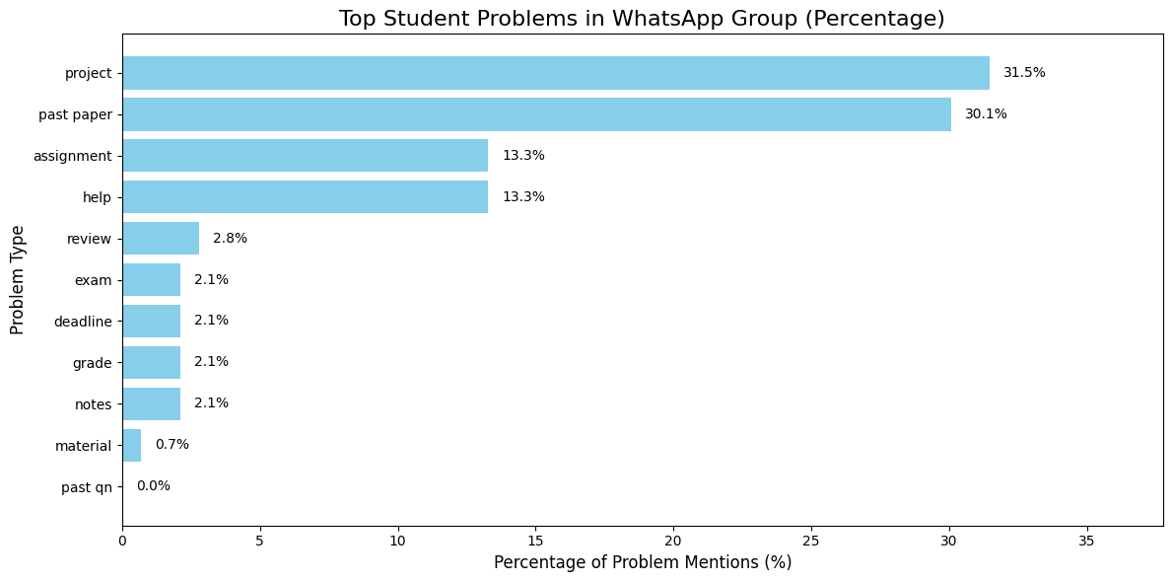

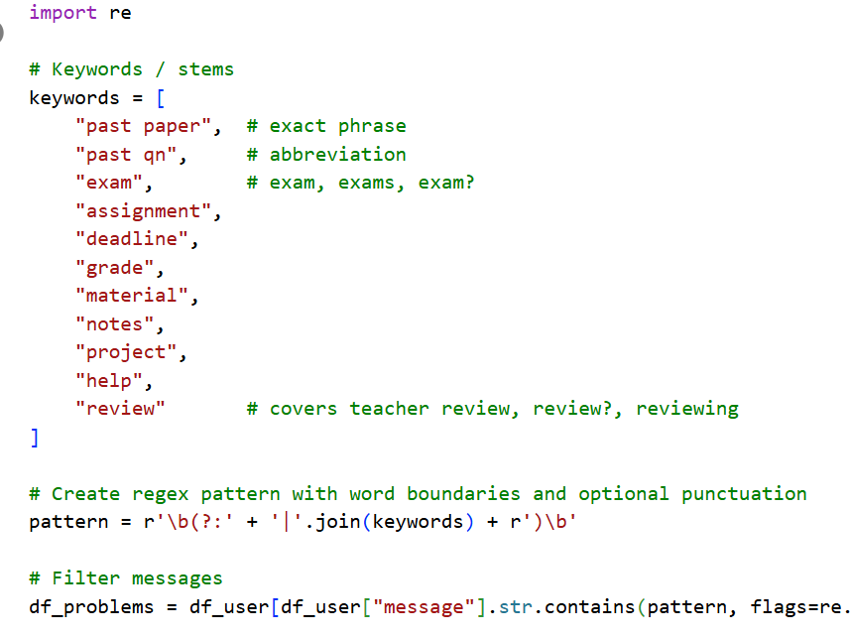
Students are in very strong need of the past papers. They keep asking for each other for past papers.

Solution
We designed a unified platform for all university students (9 faculties) to download the past papers.
